**Ex no 6: Implementation of Pi calculation and Matrix multiplication using Broadcast communication**

* **Pi calculation**

#include "mpi.h"

#include <stdio.h>

#include <math.h>

int main(int argc, char *argv[]) {

int done = 0, n, myid, numprocs, i;

double PI25DT = 3.141592653589793238462643;

double mypi, pi, h, sum, x;

MPI_Init(&argc, &argv);

MPI_Comm_size(MPI_COMM_WORLD, &numprocs);

MPI_Comm_rank(MPI_COMM_WORLD, &myid);

while (1) {

if (myid == 0) {

printf("Enter the number of intervals: (0 quits) ");

scanf("%d", &n);

}

MPI_Bcast(&n, 1, MPI_INT, 0, MPI_COMM_WORLD);

if (n == 0) break;

h = 1.0 / (double) n;

sum = 0.0;

for (i = myid + 1; i <= n; i += numprocs) {

x = h * ((double)i - 0.5);

sum += 4.0 / (1.0 + x*x);

}

mypi = h * sum;

MPI_Reduce(&mypi, &pi, 1, MPI_DOUBLE, MPI_SUM, 0, MPI_COMM_WORLD);

if (myid == 0)

printf("pi is approximately %.16f, Error is %.16f\n",

pi, fabs(pi - PI25DT));

break; // Exit loop after calculating and printing pi value

} MPI_Finalize();

return 0;

}

**Output:**

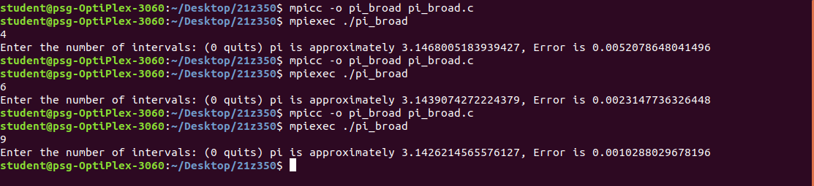

* **Matrix multiplication**

#include <stdlib.h>

#include <stdio.h>

#include "mpi.h"

#include <time.h>

#include <sys/time.h>

// Number of rows and columns in a matrix

#define N 4

MPI_Status status;

// Matrix holders are created

double matrix_a[N][N], matrix_b[N][N], matrix_c[N][N];

int main(int argc, char **argv) {

int processCount, processId, slaveTaskCount, source, rows, offset;

struct timeval start, stop;

MPI_Init(&argc, &argv);

MPI_Comm_rank(MPI_COMM_WORLD, &processId);

MPI_Comm_size(MPI_COMM_WORLD, &processCount);

slaveTaskCount = processCount - 1;

if (processId == 0) {

srand(time(NULL));

for (int i = 0; i < N; i++) {

for (int j = 0; j < N; j++) {

matrix_a[i][j] = rand() % 10;

matrix_b[i][j] = rand() % 10;

}

}

printf("\n\t\tMatrix - Matrix Multiplication using MPI\n");

printf("\nMatrix A\n\n");

for (int i = 0; i < N; i++) {

for (int j = 0; j < N; j++) {

printf("%.0f\t", matrix_a[i][j]);

}

printf("\n");

}

printf("\nMatrix B\n\n");

for (int i = 0; i < N; i++) {

for (int j = 0; j < N; j++) {

printf("%.0f\t", matrix_b[i][j]);

}

printf("\n");

}

rows = N / slaveTaskCount;

offset = 0;

// Broadcast matrix_a and matrix_b to all processes

MPI_Bcast(matrix_a, N * N, MPI_DOUBLE, 0, MPI_COMM_WORLD);

MPI_Bcast(matrix_b, N * N, MPI_DOUBLE, 0, MPI_COMM_WORLD);

for (int dest = 1; dest <= slaveTaskCount; dest++) {

MPI_Send(&offset, 1, MPI_INT, dest, 1, MPI_COMM_WORLD);

MPI_Send(&rows, 1, MPI_INT, dest, 1, MPI_COMM_WORLD);

offset = offset + rows;

}

for (int i = 1; i <= slaveTaskCount; i++) {

source = i;

MPI_Recv(&offset, 1, MPI_INT, source, 2, MPI_COMM_WORLD, &status);

MPI_Recv(&rows, 1, MPI_INT, source, 2, MPI_COMM_WORLD, &status);

MPI_Recv(&matrix_c[offset][0], rows * N, MPI_DOUBLE, source, 2, MPI_COMM_WORLD, &status);

}

printf("\nResult Matrix C = Matrix A * Matrix B:\n\n");

for (int i = 0; i < N; i++) {

for (int j = 0; j < N; j++)

printf("%.0f\t", matrix_c[i][j]);

printf("\n");

}

printf("\n");

}

if (processId > 0) {

// Broadcast matrix_a and matrix_b to all slave processes

MPI_Bcast(matrix_a, N * N, MPI_DOUBLE, 0, MPI_COMM_WORLD);

MPI_Bcast(matrix_b, N * N, MPI_DOUBLE, 0, MPI_COMM_WORLD);

MPI_Recv(&offset, 1, MPI_INT, 0, 1, MPI_COMM_WORLD, &status);

MPI_Recv(&rows, 1, MPI_INT, 0, 1, MPI_COMM_WORLD, &status);

for (int k = 0; k < N; k++) {

for (int i = 0; i < rows; i++) {

matrix_c[i][k] = 0.0;

for (int j = 0; j < N; j++)

matrix_c[i][k] += matrix_a[i][j] * matrix_b[j][k];

}

}

MPI_Send(&offset, 1, MPI_INT, 0, 2, MPI_COMM_WORLD);

MPI_Send(&rows, 1, MPI_INT, 0, 2, MPI_COMM_WORLD);

MPI_Send(&matrix_c, rows * N, MPI_DOUBLE, 0, 2, MPI_COMM_WORLD);

}

MPI_Finalize();

return 0;

}

**Output:**

